

**Castor title description**

**Wheel title description**

ORDER CODE

$XX.00 each plus GST

Insert

XX mm

XX x XX mm

XX x XX mm

XX kg

Insert

XX mm

Insert

Price per castor

Description

Overall height

Bolt hole pattern

Plate size

Load rating

Designer thread guard

Wheel type

Wheel diameter

ORDER CODE

Product code

ORDER CODE

Wheel diameter

Tread width

Wheel type

Rim

Bearing type

Load rating

Hub width

Description

$XX.00 plus GST

Insert

XX mm

XX mm

XX mm

Insert

Insert

Insert

XX kg

XX mm

Product code

ORDER CODE

Bore diameter

Price per wheel

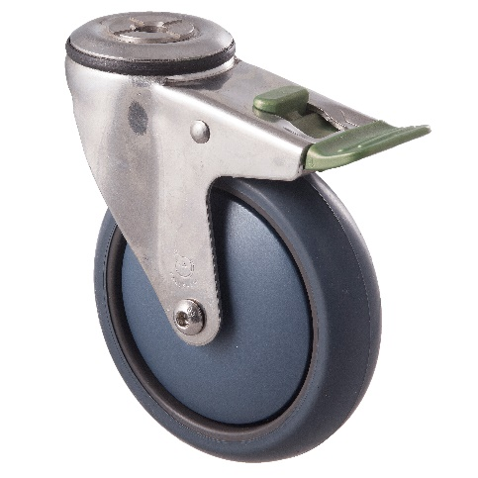

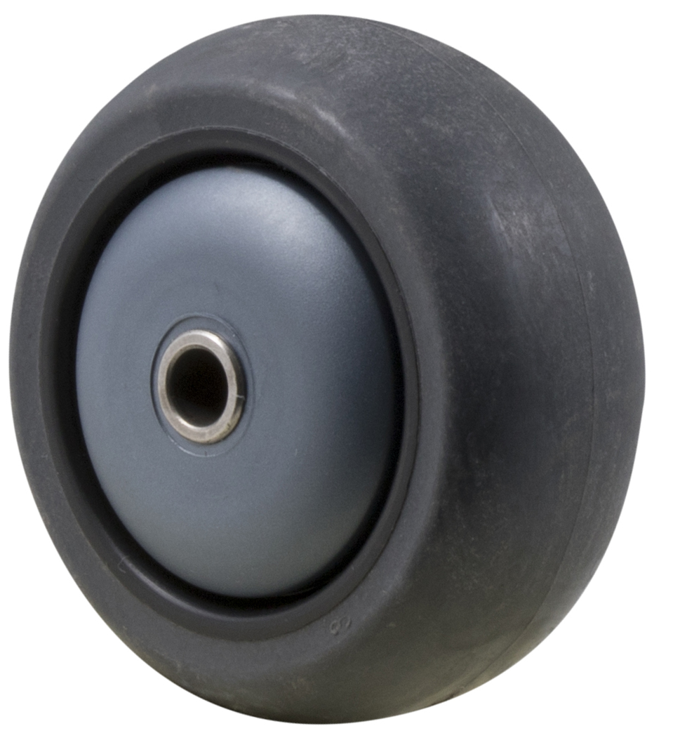

$ xx.xx (+GST)

$ xx.xx (+GST)



**Castor title description**

**Wheel title description**

ORDER CODE

$XX.00 each plus GST

Insert

XX mm

XX x XX mm

XX x XX mm

XX kg

Insert

XX mm

Insert

Price per castor

Description

Overall height

Bolt hole pattern

Plate size

Load rating

Designer thread guard

Wheel type

Wheel diameter

ORDER CODE

Product code

ORDER CODE

Wheel diameter

Tread width

Wheel type

Rim

Bearing type

Load rating

Hub width

Description

$XX.00 plus GST

Insert

XX mm

XX mm

XX mm

Insert

Insert

Insert

XX kg

XX mm

Product code

ORDER CODE

Bore diameter

Price per wheel

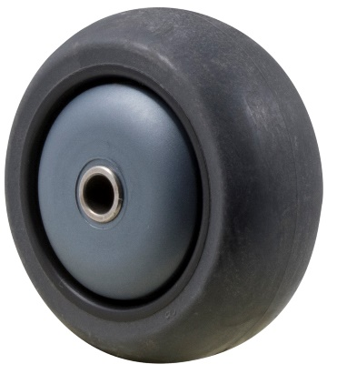

$ xx.xx (+GST)

$ xx.xx (+GST)



**Castor title description**

**Wheel title description**

ORDER CODE

$XX.00 each plus GST

Insert

XX mm

XX x XX mm

XX x XX mm

XX kg

Insert

XX mm

Insert

Price per castor

Description

Overall height

Bolt hole pattern

Plate size

Load rating

Designer thread guard

Wheel type

Wheel diameter

ORDER CODE

Product code

ORDER CODE

Wheel diameter

Tread width

Wheel type

Rim

Bearing type

Load rating

Hub width

Description

$XX.00 plus GST

Insert

XX mm

XX mm

XX mm

Insert

Insert

Insert

XX kg

XX mm

Product code

ORDER CODE

Bore diameter

Price per wheel



$ xx.xx (+GST)

$ xx.xx (+GST)